Working document

Prediction tools: backbone infrastructure documentation

Project name: | Q-ImPrESS
Contract number: | FP7-215013
Project deliverable: | Working document – Prediction tools: backbone infrastructure documentation
Author(s): | Michal Malohlava
Work package: | WP4
Work package leader: | CUNI
Planned delivery date: | -
Delivery date: | -
Last change: | 2009-08-21
Version number: | 0.1

Abstract
This document describes backbone infrastructure based on Eclipse plug-ins. It provides details about every plug-in and its contribution. Further, it includes a description of a public API for manipulation with models and their alternatives.

Keywords: prediction tools, repository, plug-in, backbone infrastructure, API

Revision history

Version | Change date | Author(s) | Description
0.1 | 2009-08-13 | Michal Malohlava | Initial contribution

Table of contents
1 Backbone infrastructure introduction 3
2 Backbone infrastructure plug-ins 3
2.1 Backbone core 4
2.1.1 Application meta-model 4
2.1.2 Application meta-model resource mapping and implementation 5
2.2 Backbone core UI 5
2.2.1 Resource model visualization 7
2.2.2 Actions 7
2.2.3 Integration with editors 7
2.3 Backbone analysis support 7
3 Public API 9
3.1 IQApplicationModel 9
3.2 IQProject 9
3.3 IQRepository 9
3.4 IQAlternative 9
3.5 IQModel 9
Backbone infrastructure introduction
The backbone infrastructure consists of several Eclipse plug-ins providing basic functionality which can be divided into the following groups:
- Application meta-model defining relation between application elements (alternatives, models, projects) and publishing API for manipulation with these elements.
- Analysis support including
  - Meta-models for defining analysis models
  - Common analysis interface
  - Extension point to plug new analysis methods
- UI contributions
  - Q-ImPrESS project nature and builders
  - Visualization of the application model in Project Explorer view
  - Launch configuration to execute defined analysis methods
  - Integration of meta-models edit functionality with the application model

Backbone infrastructure plug-ins
The groups of functionality are reflected in the structure of plug-ins:

Application meta-model
- eu.qimpress.ide.backbone.core
  - defines the application meta-model and its mapping on underlying resources (files, directories, projects, workspaces)

Analysis support
- eu.qimpress.ide.backbone.analysis
  - provides IAnalysisTool interface, extension point for registration new analysis methods and a launch configuration.
- eu.qimpress.ide.backbone.analysis.core
  - defines simple analysis meta-model
- eu.qimpress.ide.backbone.analysis.core.edit
- eu.qimpress.ide.backbone.analysis.generic
  - defines generic analysis meta-model extending the core meta-model by providing a notion of an analysis attribute and its value.
- eu.qimpress.ide.backbone.analysis.generic.edit
- eu.qimpress.ide.backbone.analysis.generic.editor

UI contributions
- eu.qimpress.ide.backbone.core.ui
  - visualizes an application model in Project Explorer view.
- eu.qimpress.ide.backbone.core.ui.models
  - integrates predefined meta-models edit functionality into the visualization of the application model.

The following sections describe particular plug-ins:

Backbone core

Plug-in ID: eu.qimpress.ide backbone.core
This plug-in defines an application meta-model and its mapping to appropriate workspace resources (projects, files, and folders). The application meta-model API is published by the package eu.qimpress.ide.backbone.core.model. The implementation of the application meta-model is stored in package eu.qimpress.ide.backbone.core.internal.model.

Application meta-model
The application meta-model follows the idea of version alternatives containing different models conforming to predefined meta-models (SAMM, Seff). Further, it defines an abstraction of a Q-ImPrESS project and a runtime workspace to simplify manipulation with Q-ImPrESS projects at runtime.

Current working area consists of several projects with Q-ImPrESS nature. They are represented by the entity IQProject. These projects are managed by the entity IQApplicationModel which is unique top-level entity provided by QImpressApplicationModelManager.

Each project contains a repository (IQRepository) of version alternatives (IQAlternative). Alternatives compose a tree where the root of the tree is represented by the alternative repository. Each alternative can have several child alternatives created as copies of parent alternative. The alternative maintains and provides a set of models (IQModel).

One alternative is selected as a default working alternative which provides a current working model set.

The singleton QImpressApplicationModelManager serves as a primary and preferred access point to obtain a reference to IQApplicationModel which can be used to list repositories, alternatives and models.

Application meta-model resource mapping
Application model elements are mapped to appropriate underlying Eclipse workspace entities in the following way:

- IQApplicationModel corresponds to a current working workspace (IWorkspace).
- IQProject corresponds to a particular project (IProject) in the current working workspace.
- IQRepository is mapped to a specific project folder called ‘alternatives’ (IFolder).
- IQAlternative corresponds to a folder (IFolder) stored in a repository folder (called ‘alternatives’) at it is named according to alternative ID.
- IQModel is mapped to an appropriate model file (IFile) stored in the alternative folder. Only predefined types of files (recognized by an extension) are allowed to act as model files.

Implementation of IQRepository internally manages a relation between alternatives by storing their configuration into object database (Neodatis). The object database is stored as the ‘.db’ file in the repository folder.

Predefined model files
- SAMM Static structure: samm_repository
- SAMM Service architecture model: samm_servicearchitecturemodel
- SAMM Hardware model: samm_hardware
- SAMM QoS annotations model: samm_qosannotations
- SAMM Target environment model: samm_targetenvironment
- SAMM Usage model: samm_usagemodel

Backbone core UI

Plug-in ID: eu.qimpress.ide backbone.core.ui
This plug-in visualizes defined application model by providing the Project Explorer view a content (ID: eu.qimpress.ide.backbone.core.ui.content.navigatorContent) and action extension. The content extension works with the application model and appends two new nodes into the Project Explorer view – default alternative and repository node (see Figure 1).
The default alternative node represents a current working set of models. Each model is shown as a child node of the default alternative. The content of the model node is further presented by a separated plugin eu.qimpress.ide.backbone.core.ui.models.
The repository node represents a tree-structure of version alternatives.

The core UI plugin publish actions to create a new alternative, delete an alternative and select an alternative as a default alternative.

Further, the plugin defines a Q-ImPrESS project nature (ID: eu.qimpress.ide.backbone.core.ui.QImpressNature) and an associated builder which check the consistency of the alternatives repository and underlying models.

Plug-in ID: eu.qimpress.ide backbone.core.ui.models
The plug-in integrates visualization of underlying models with the nodes provided by plugin eu.qimpress.ide.backbone.core.ui. According to a model file it shows the model entities as child of the model node. For this functionality it reuses generated *.edit projects for the defined meta-models.
The visualization is based on providing a new navigator content extension (ID: eu.qimpress.ide.backbone.core.ui.models.content.SammModelContentExtension) including a action provider. The content extension encapsulates EMF AdapterFactoryContentProvider to integrate generated code of *.edit projects of predefined meta-models. Meta-models (in fact meta-model packages) which processed by the extension are listed in the class QModelsComposedAdapterFactoryProvider.
The action provider provides actions for manipulation with models.

The edit support for models is managed by ShadowModelEditor serving as an EMF EditingDomain provider (EMF abstraction standing on the top of ResourceSet and operated by meta-model *.edit projects). ShadowModelEditor is associated with the default working alternative and provides API for loading EMF resources from model files (see IQModel).

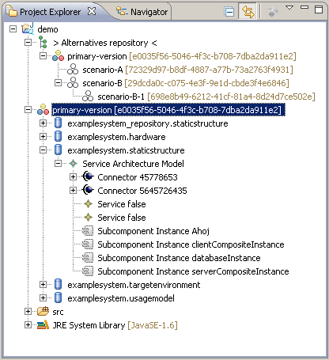
Figure 1 - The Project Explorer view.

Actions
TODO

Integration with editors
The plug-in itself does not provide any API to integrate editors. The recommended way is to declare action provider which will be enabled just for required entities and which will open the editor with an appropriately configured input.

Backbone analysis support

Plug-in ID: eu.qimpress.ide backbone.analysis
This plug-in defines an interface IAnalysisTool which is should be implemented by plug-ins providing new analysis methods.
To inform the plug-in about new analysis methods, the plug-in defines extension point (ID: tools – see file scheme/tools.exsd) which has to be filled by a plug-in publishing new analysis method.
The extension point declares these compulsory fields:
- ID – an identifier of the analysis method
- class – a Java class implementing IAnalysisTool interface

The plugin contributes into UI by providing a Q-ImPrESS launch configuration. (see ).

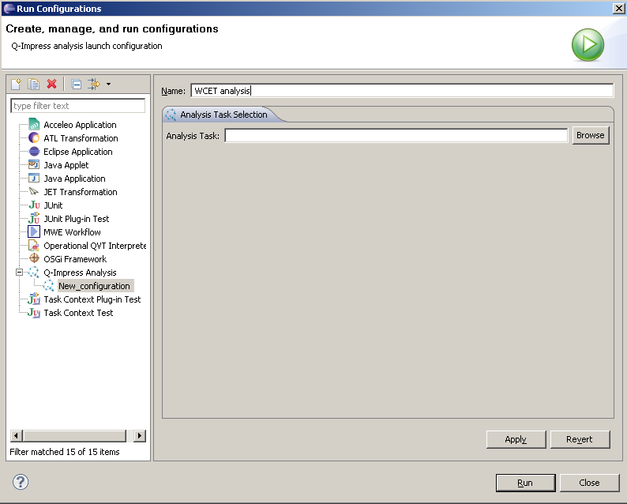
Figure 2 - Q-ImPrESS launch configuration

Plug-in ID: eu.qimpress.ide backbone.analysis.core
This plug-in defines the core analysis meta-model (see Figure 3). The meta-model consists of one entity AnalysisTask containing a property tool which specifies ID of an analysis method registered via the extension point published by plug-in eu.qimpress.ide.backbone.analysis.
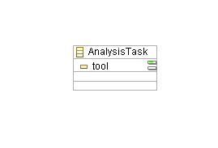
Figure 3 - analysis core meta-model

Plug-in ID: eu.qimpress.ide backbone.analysis.generic
The plug-in provides a generic analysis meta-model extending the core analysis meta-model provided by plug-in eu.qimpress.ide backbone.analysis.core. It introduces GenericAnalysisTask encapsulating analysis parameters. The analysis parameter is defined as a tuple consisting of a parameter name and parameter value.
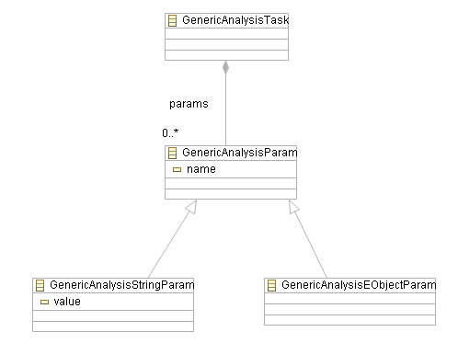
Figure 4 - generic analysis meta-model

Public API

IQApplicationModel

IQProject

IQRepository

IQAlternative

IQModel

